**Create flow that stores document in SharePoint**

Steps to follow

1. Create an instant flow
2. Add file input
3. Add Create file action from SharePoint
4. Select the Site
5. Enter the Library name
6. Create a file name using expression from the uploaded file
   1. String(triggerBody()?[‘file’]?[‘name’])
7. Assign the file content
   1. 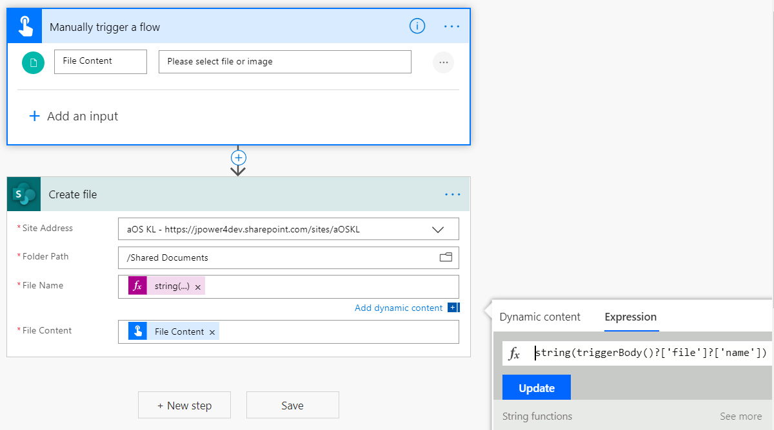
8. Save and test the flow
9. Upload image or document, it will upload the document in SharePoint library.